# PRÁCTICA 4: FUNDAMENTOS DE LOS COMPUTADORES

**Ejercicio 1:**

1) Escribe su tabla de verdad

|  |  |  |  |  |  |
| --- | --- | --- | --- | --- | --- |
| NUM | A | B | C | D | f |
| 0 | 0 | 0 | 0 | 0 | X |
| 1 | 0 | 0 | 0 | 1 | 1 |
| 2 | 0 | 0 | 1 | 0 | 1 |
| 3 | 0 | 0 | 1 | 1 | 0 |
| 4 | 0 | 1 | 0 | 0 | 1 |
| 5 | 0 | 1 | 0 | 1 | 1 |
| 6 | 0 | 1 | 1 | 0 | 0 |
| 7 | 0 | 1 | 1 | 1 | 1 |
| 8 | 1 | 0 | 0 | 0 | 1 |
| 9 | 1 | 0 | 0 | 1 | 0 |
| 10 | 1 | 0 | 1 | 0 | 1 |
| 11 | 1 | 0 | 1 | 1 | X |
| 12 | 1 | 1 | 0 | 0 | 0 |
| 13 | 1 | 1 | 0 | 1 | 0 |
| 14 | 1 | 1 | 1 | 0 | 1 |
| 15 | 1 | 1 | 1 | 1 | 0 |

2) Obtén su equivalente en forma de producto de sumas.

g=(A+B+C’+D’)*(A+B’+C’+D)*(A’+B+C+D’)*(A’+B’+C+D)*(A’+B’+C+D’)*(A’+B’+C’+D’)

3) Simplifica la tabla de verdad e indica la expresión obtenida.

|  |  |  |  |  |
| --- | --- | --- | --- | --- |
| AB/CD | 00 | 01 | 11 | 10 |
| 00 | X | 1 | 0 | 1 |
| 01 | 1 | 1 | 1 | 0 |
| 11 | 0 | 0 | 0 | 1 |
| 10 | 1 | 0 | X | 1 |

F=(A’+B’+C)(A’+D’)(B+C’+D’)(A+B’+C’+D)

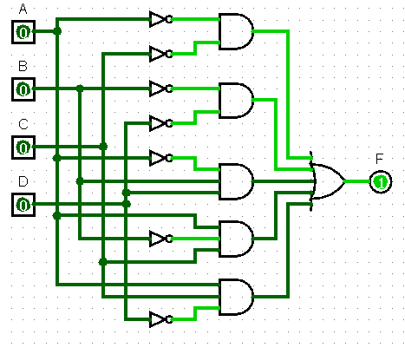4) Haciendo uso de LogiSim, implementa la función simplificada con el menor número de puertas básicas posible.

5) Comprueba que la tabla de verdad del circuito implementado coincide con la original.

|  |  |  |  |  |  |
| --- | --- | --- | --- | --- | --- |
| **NUM** | **A** | **B** | **C** | **D** | **f** |
| **0** | 0 | 0 | 0 | 0 | X |
| **1** | 0 | 0 | 0 | 1 | 1 |
| **2** | 0 | 0 | 1 | 0 | 1 |
| **3** | 0 | 0 | 1 | 1 | 0 |
| **4** | 0 | 1 | 0 | 0 | 1 |
| **5** | 0 | 1 | 0 | 1 | 1 |
| **6** | 0 | 1 | 1 | 0 | 0 |
| **7** | 0 | 1 | 1 | 1 | 1 |
| **8** | 1 | 0 | 0 | 0 | 1 |
| **9** | 1 | 0 | 0 | 1 | 0 |
| **10** | 1 | 0 | 1 | 0 | 1 |
| **11** | 1 | 0 | 1 | 1 | X |
| **12** | 1 | 1 | 0 | 0 | 0 |
| **13** | 1 | 1 | 0 | 1 | 0 |
| **14** | 1 | 1 | 1 | 0 | 1 |
| **15** | 1 | 1 | 1 | 1 | 0 |

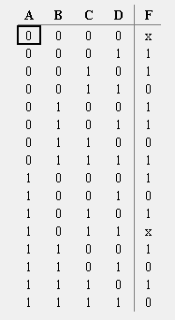

Como podemos ver, las tablas de verdad coinciden.

**Ejercicio 2:**

a) Escribe su tabla de verdad

|  |  |  |  |  |  |
| --- | --- | --- | --- | --- | --- |
| **NUM** | **A** | **B** | **C** | **D** | **f** |
| **0** | 0 | 0 | 0 | 0 | 1 |
| **1** | 0 | 0 | 0 | 1 | 0 |
| **2** | 0 | 0 | 1 | 0 | 1 |
| **3** | 0 | 0 | 1 | 1 | 1 |
| **4** | 0 | 1 | 0 | 0 | 1 |
| **5** | 0 | 1 | 0 | 1 | 0 |
| **6** | 0 | 1 | 1 | 0 | 1 |
| **7** | 0 | 1 | 1 | 1 | 0 |
| **8** | 1 | 0 | 0 | 0 | 1 |
| **9** | 1 | 0 | 0 | 1 | 1 |
| **10** | 1 | 0 | 1 | 0 | 1 |
| **11** | 1 | 0 | 1 | 1 | 0 |
| **12** | 1 | 1 | 0 | 0 | 1 |
| **13** | 1 | 1 | 0 | 1 | 0 |
| **14** | 1 | 1 | 1 | 0 | 1 |
| **15** | 1 | 1 | 1 | 1 | 1 |

b) Construye la tabla de Karnaugh asociada y agrupa los unos de la forma indicada en la introducción teórica. Obtén la expresión algebraica simplificada de la salida en forma de suma de productos.

|  |  |  |  |  |
| --- | --- | --- | --- | --- |
| AB/CD | 00 | 01 | 11 | 10 |
| 00 | 1 | 0 | 1 | 1 |
| 01 | 1 | 0 | 0 | 1 |
| 11 | 1 | 0 | 1 | 1 |
| 10 | 1 | 1 | 0 | 1 |

F=D’+A’B’C+ABC+AB’C’

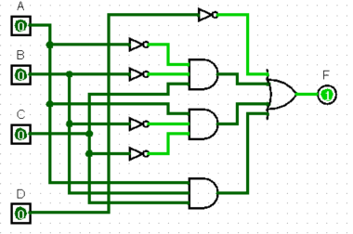 c) Implementa en LogiSim dicha expresión utilizando las puertas lógicas necesarias.

d) Vuelve a simplificar la tabla de Karnaugh anterior de forma que la expresión quede ahora en forma de producto de sumas. Impleméntala y comprueba que su tabla de verdad coincide con la original.

|  |  |  |  |  |
| --- | --- | --- | --- | --- |
| AB/CD | 00 | 01 | 11 | 10 |
| 00 | 1 | 0 | 1 | 1 |
| 01 | 1 | 0 | 0 | 1 |
| 11 | 1 | 0 | 1 | 1 |
| 10 | 1 | 1 | 0 | 1 |

F=(A + C + D’) (A + B’ + D’) (B’ + C + D’) (A’ + B + C’ + D)

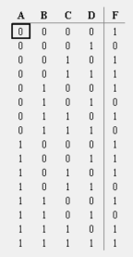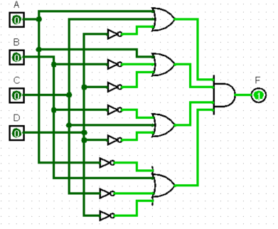

Como podemos observar, tanto simplificando la función con suma de productos como con producto de sumas, las tablas de verdad son iguales.

**Ejercicio 3:**

|  |  |  |  |  |  |  |
| --- | --- | --- | --- | --- | --- | --- |
| NUM | A | B | C | D | E | f |
| 0 | 0 | 0 | 0 | 0 | 0 | 1 |
| 1 | 0 | 0 | 0 | 0 | 1 | 0 |
| 2 | 0 | 0 | 0 | 1 | 0 | 0 |
| 3 | 0 | 0 | 0 | 1 | 1 | 1 |
| 4 | 0 | 0 | 1 | 0 | 0 | 0 |
| 5 | 0 | 0 | 1 | 0 | 1 | 0 |
| 6 | 0 | 0 | 1 | 1 | 0 | 0 |
| 7 | 0 | 0 | 1 | 1 | 1 | 1 |
| 8 | 0 | 1 | 0 | 0 | 0 | 0 |
| 9 | 0 | 1 | 0 | 0 | 1 | 0 |
| 10 | 0 | 1 | 0 | 1 | 0 | 1 |
| 11 | 0 | 1 | 0 | 1 | 1 | 1 |
| 12 | 0 | 1 | 1 | 0 | 0 | 1 |
| 13 | 0 | 1 | 1 | 0 | 1 | 1 |
| 14 | 0 | 1 | 1 | 1 | 0 | 1 |
| 15 | 0 | 1 | 1 | 1 | 1 | 0 |
| 16 | 1 | 0 | 0 | 0 | 0 | 0 |
| 17 | 1 | 0 | 0 | 0 | 1 | 0 |
| 18 | 1 | 0 | 0 | 1 | 0 | 0 |
| 19 | 1 | 0 | 0 | 1 | 1 | 0 |
| 20 | 1 | 0 | 1 | 0 | 0 | 0 |
| 21 | 1 | 0 | 1 | 0 | 1 | 0 |
| 22 | 1 | 0 | 1 | 1 | 0 | 0 |
| 23 | 1 | 0 | 1 | 1 | 1 | 0 |
| 24 | 1 | 1 | 0 | 0 | 0 | 0 |
| 25 | 1 | 1 | 0 | 0 | 1 | 0 |
| 26 | 1 | 1 | 0 | 1 | 0 | 1 |
| 27 | 1 | 1 | 0 | 1 | 1 | 1 |
| 28 | 1 | 1 | 1 | 0 | 0 | 0 |
| 29 | 1 | 1 | 1 | 0 | 1 | 0 |
| 30 | 1 | 1 | 1 | 1 | 0 | 0 |
| 31 | 1 | 1 | 1 | 1 | 1 | 0 |

|  |  |  |  |  |  |  |  |  |
| --- | --- | --- | --- | --- | --- | --- | --- | --- |
| AB/CDE | 000 | 001 | 011 | 010 | 110 | 111 | 101 | 100 |
| 00 | 1 | 0 | 1 | 0 | 0 | 1 | 0 | 0 |
| 01 | 0 | 0 | 1 | 1 | 1 | 0 | 1 | 1 |
| 11 | 0 | 0 | 1 | 1 | 0 | 0 | 0 | 0 |
| 10 | 0 | 0 | 0 | 0 | 0 | 0 | 0 | 0 |

F=A’B’C’D’E’ + A’B’DE + BC’D’ + A’BDE + A’BCD

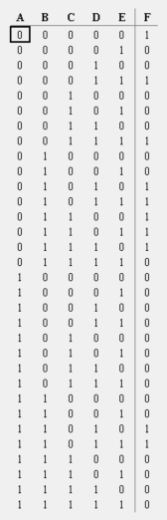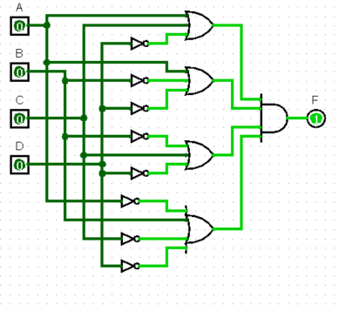

Como podemos ver, ambas tablas son iguales